How to get the files according to date and copy it to another adls

1. Create datasets using parameters as shown in previous files as well as the linked services
2. Create two more variables v1,v2 v1 variable to get the current timestamp and v2 variable to format the timestamp into ddmmyyyy format

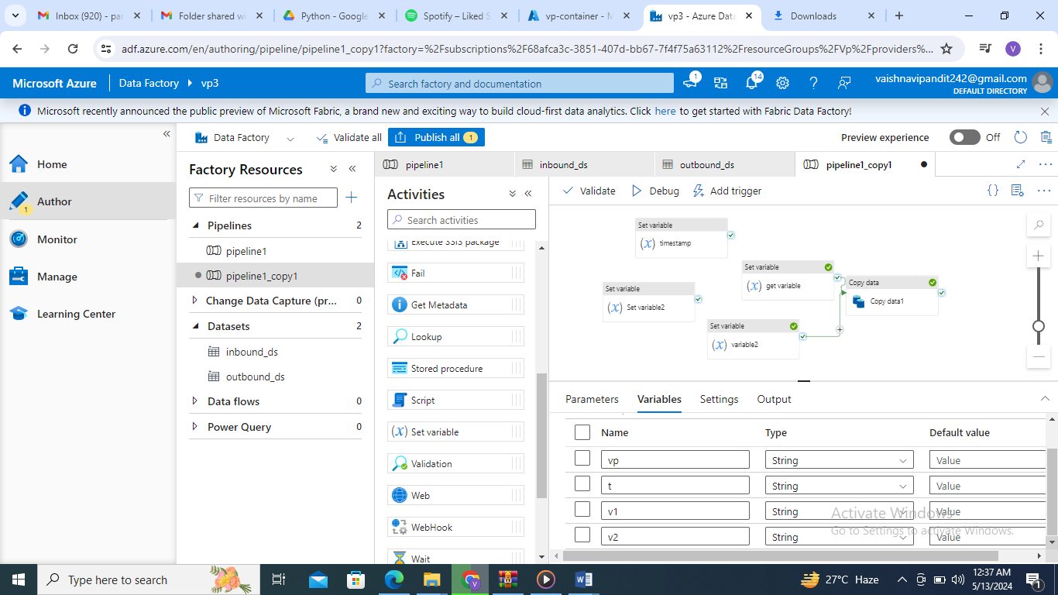

1. Now add the set activity to get the variable go to value

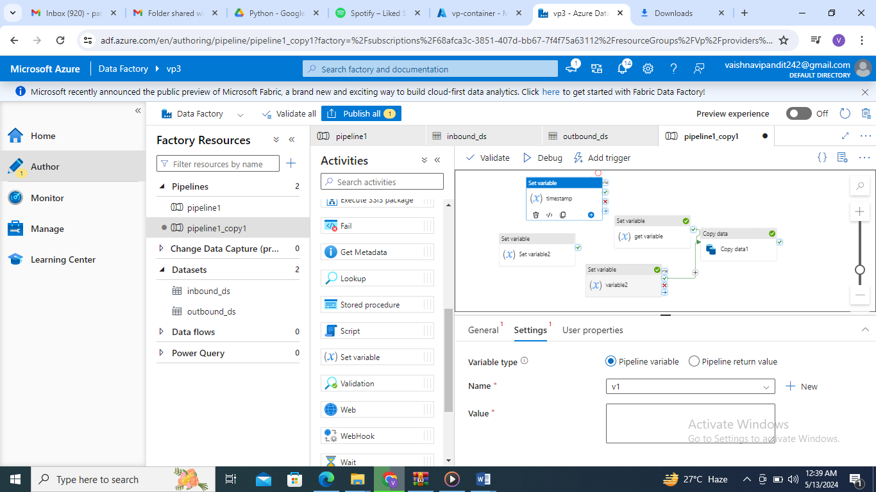

1. Now the add value using add dynamic content
2. Go to functions->date functions->utcnow

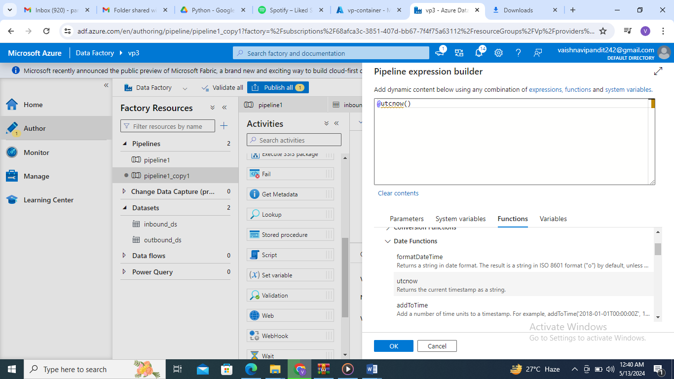

1. Now create one more set activity for formatting the timestamp

And value using add dynamic content

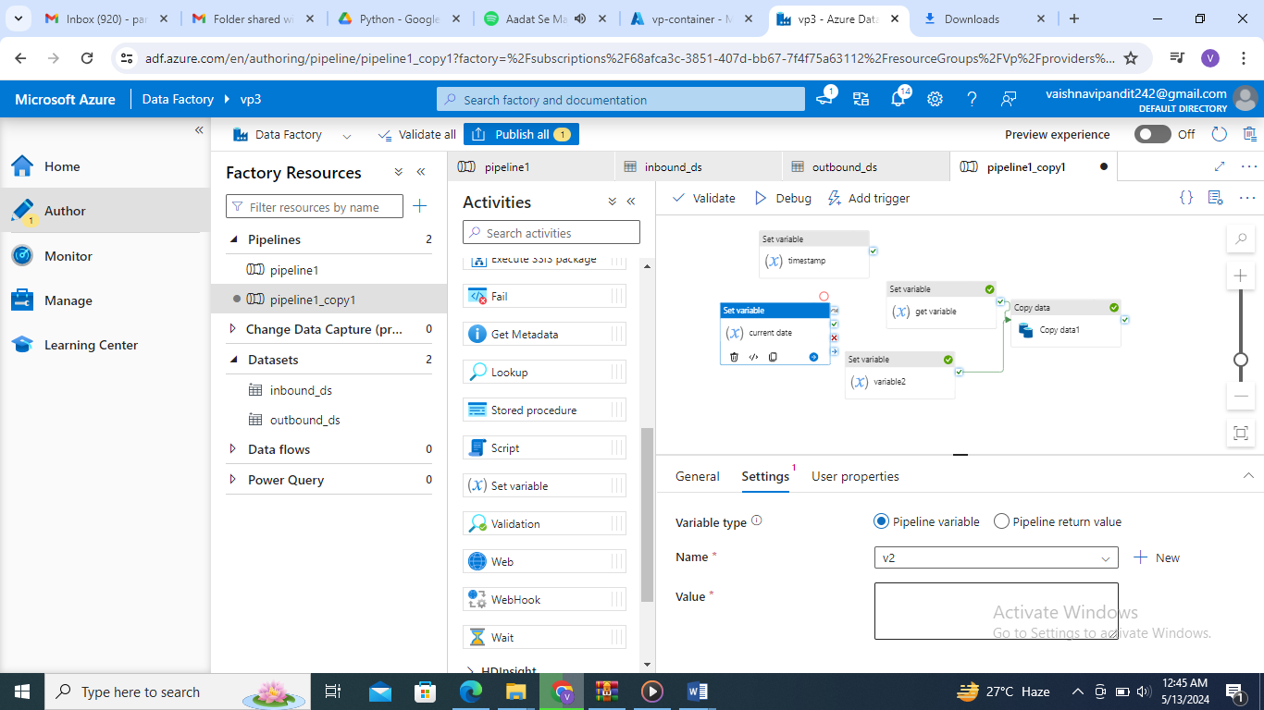

1. Go to date functions format date function and add variable v1 in the function the write format ddMMyyyy

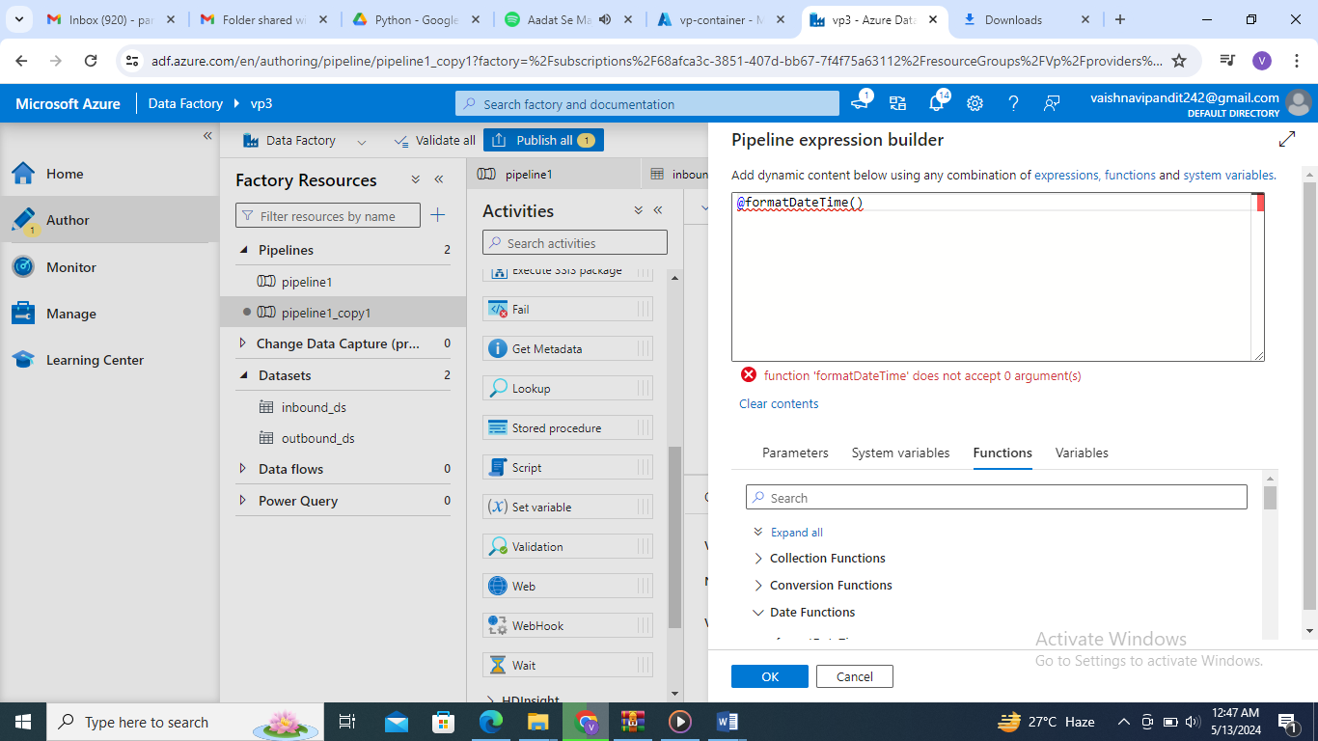

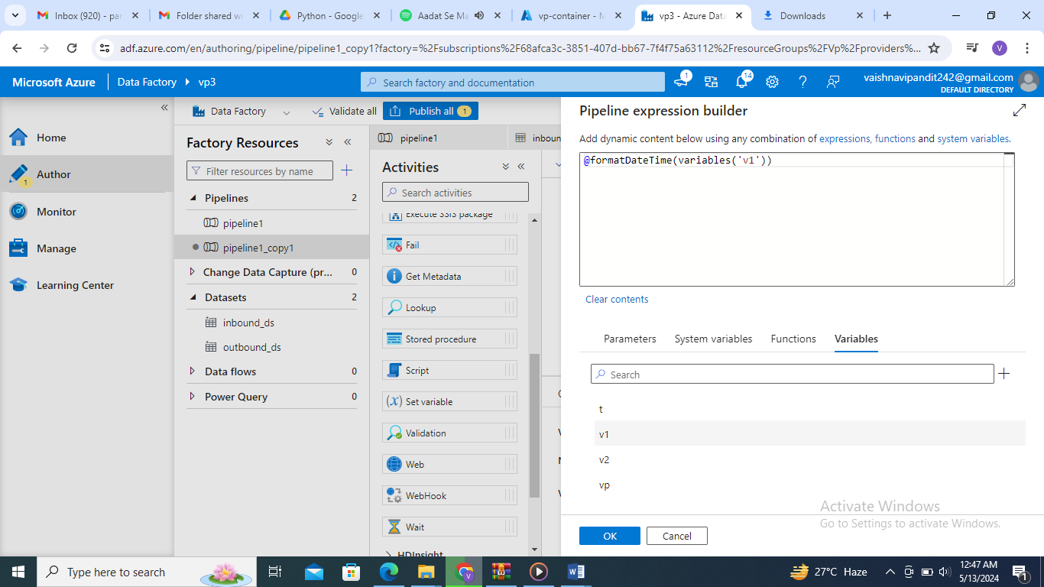

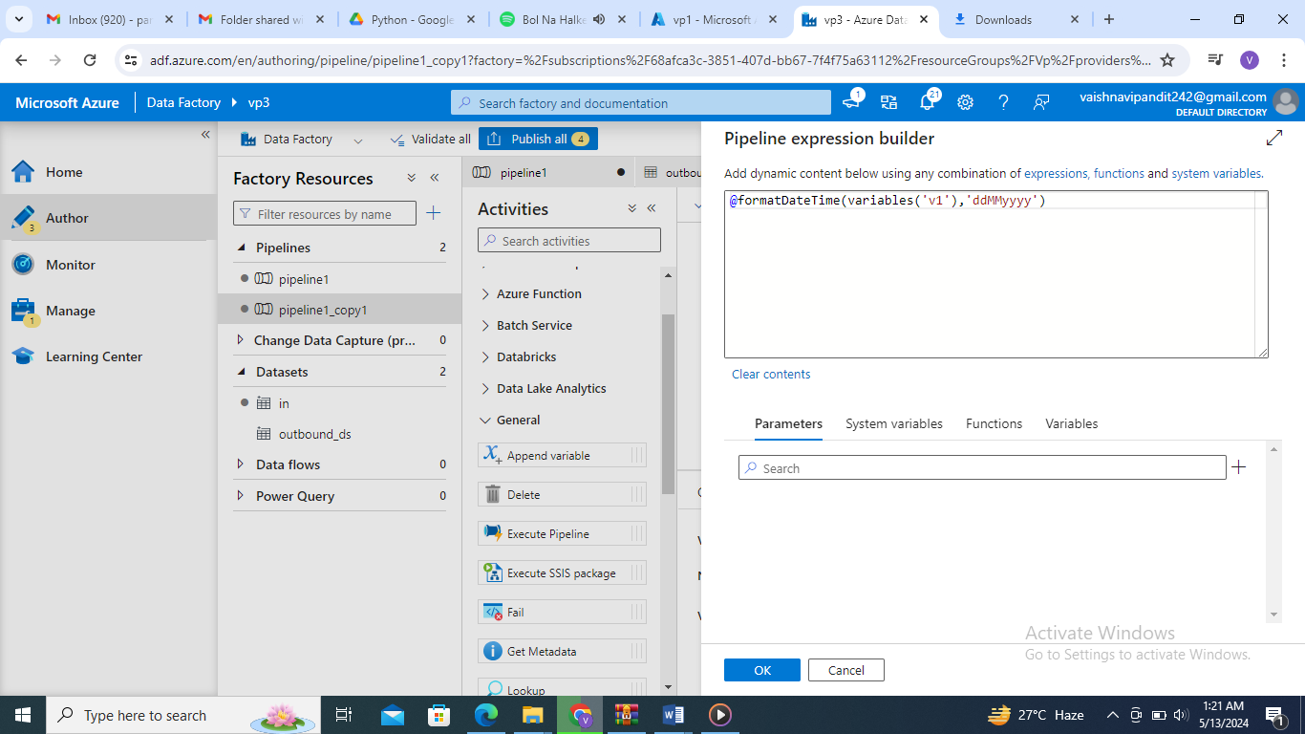

1. Now connect the activites timestamp->current date->

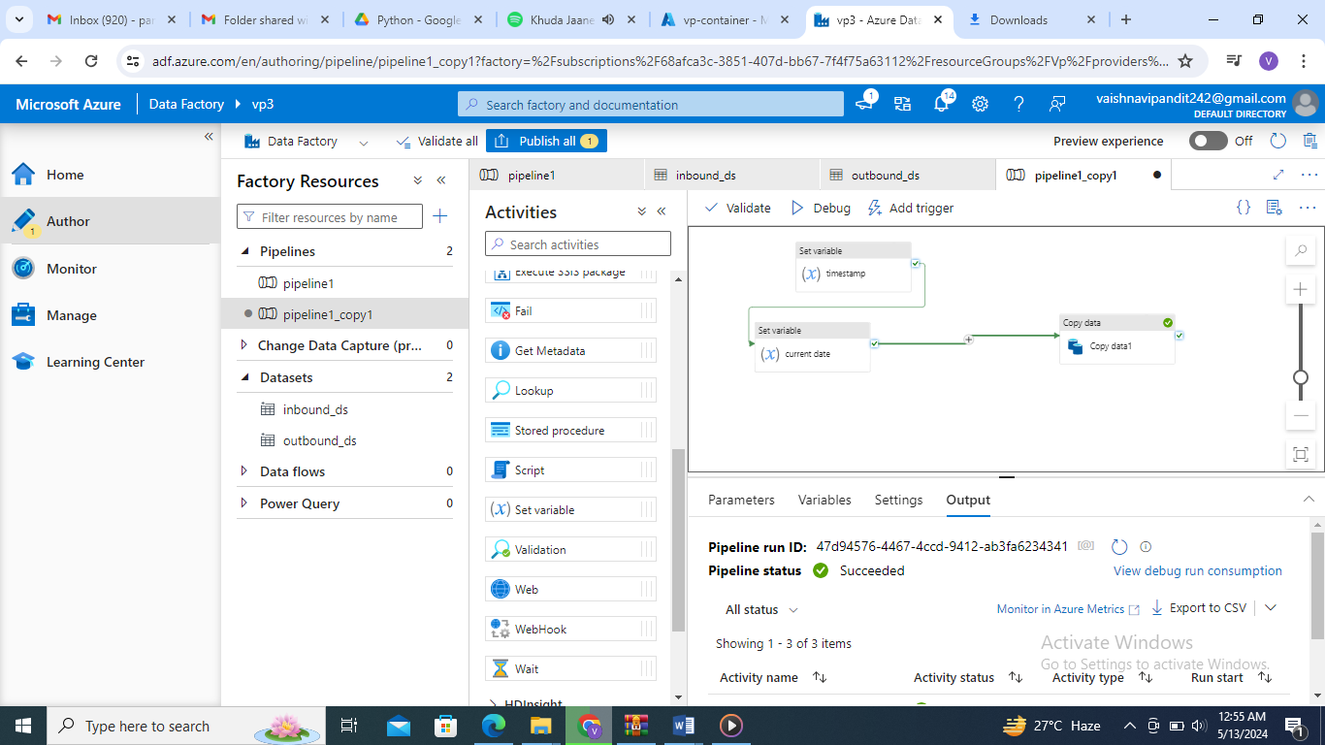

1. Now go to copy activity

In source add the variable using concat function to get todays file in the file name od_15062024.txt

